BSEF17A537
Basic Shell Commands:

Question 1:
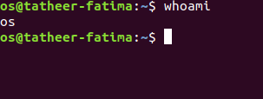

Question 2:
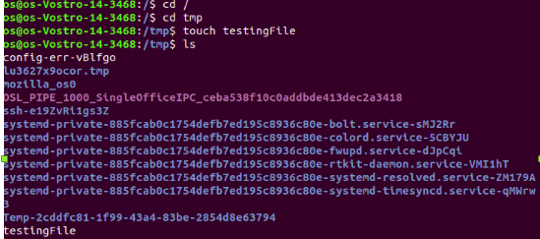

Question 3:

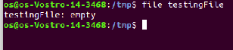

Question 4:

RMDIR COMMAND:
“rmdir” is used to remove an empty directory.
Syntax: rmdir DirectoryName

RM COMMAND:
“rm” command is used to delete an empty or non-empty directory or file. It is necessary to write “-r” with it to delete a directory containing sub directory.
Syntax: rm -r DirectoryName
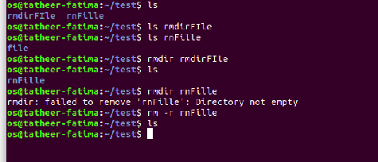

Question 5:
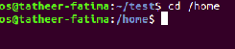

Question 6:

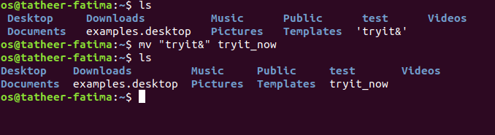

Question 7:

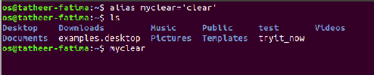

Question 8:
(a)

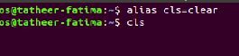

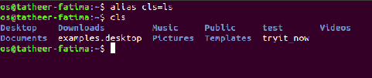

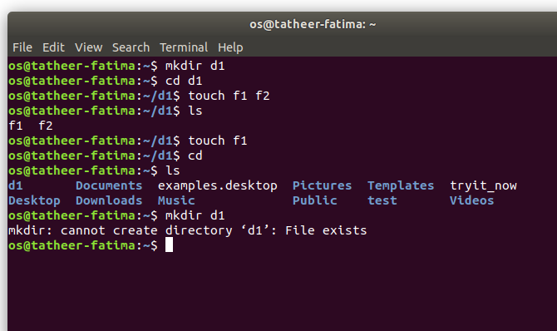
(b)

QUESTION # 2:
Question 1:

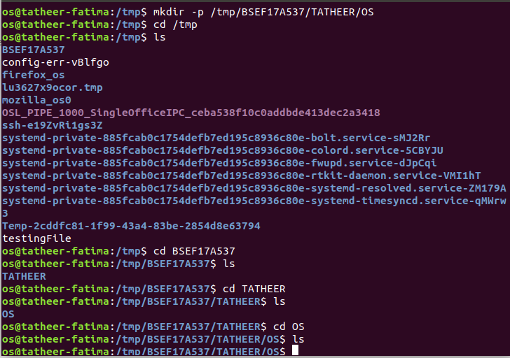

Question 2:

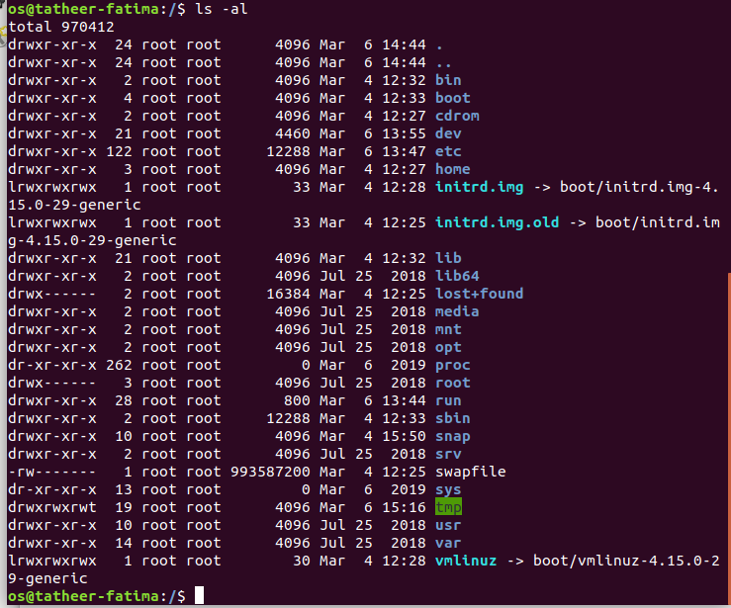

Question 3:

(a) rmdir (b) rm -r
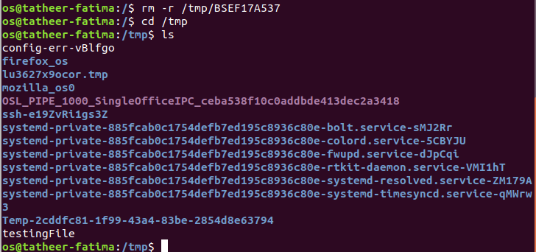

Question 4:
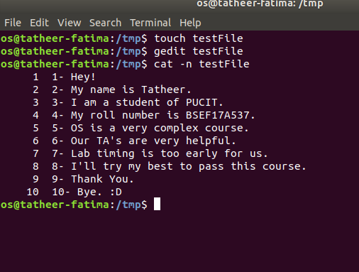

Question 5:
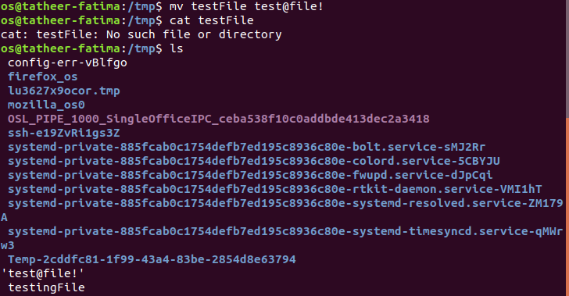
Question 6:
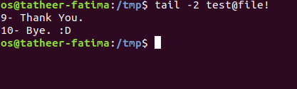

Question 7:
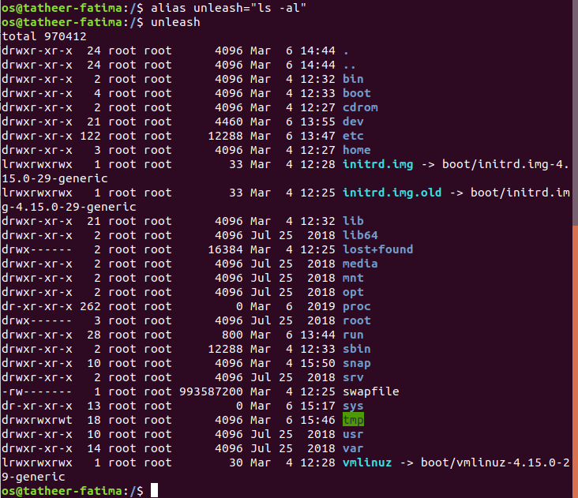

Question 8:
We use man command to see complete details of a command on the shell.

Question 9:


Question 10:
We can remove directory by using “rm -r”.
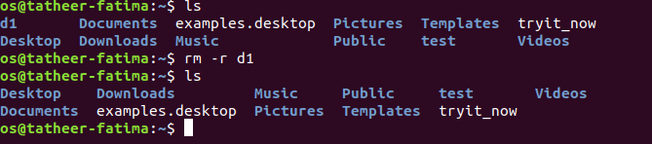

Absolute / Relative Paths:
Question 1:
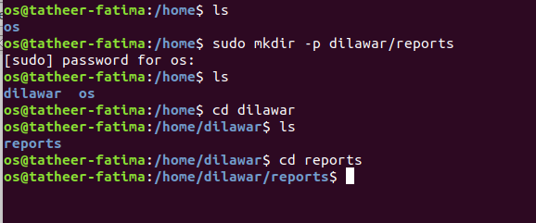
Question 2:
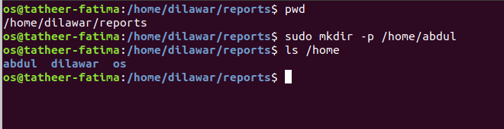

Question 3:
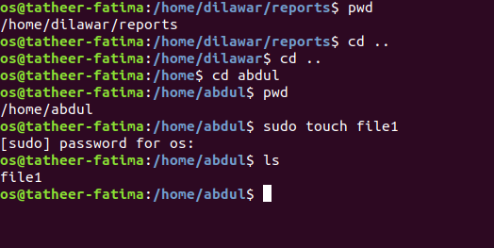
Question 4:
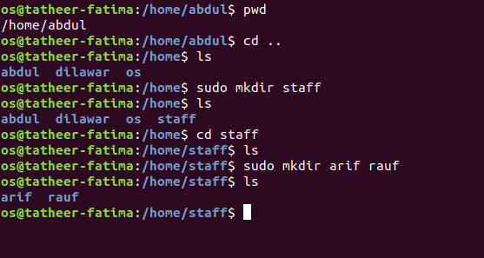

Question 5:
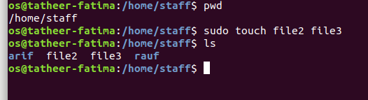
Question 6:
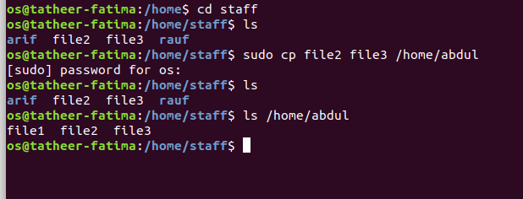
Question 7:
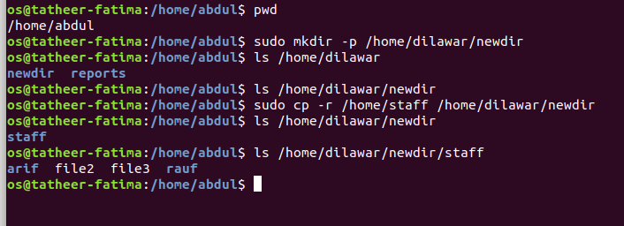
Question 8:
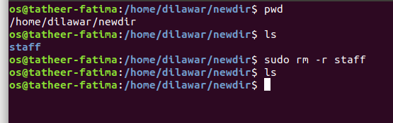
Question 9:
